**ADVANCED CODING - 2**

**CODE:**

**from typing import List**

**class Solution:**

**def trap(self, height: List[int]) -> int: if not height:**

**return 0**

**left, right = 0, len(height) - 1 left_max, right_max = 0, 0**

**water = 0**

**while left < right:**

**if height[left] < height[right]: if height[left] >= left_max:**

**left_max = height[left] else:**

**water += left_max - height[left] left += 1**

**else:**

**if height[right] >= right_max: right_max = height[right]**

**else:**

**water += right_max - height[right] right -= 1**

**return water**

**OUTPUT:**

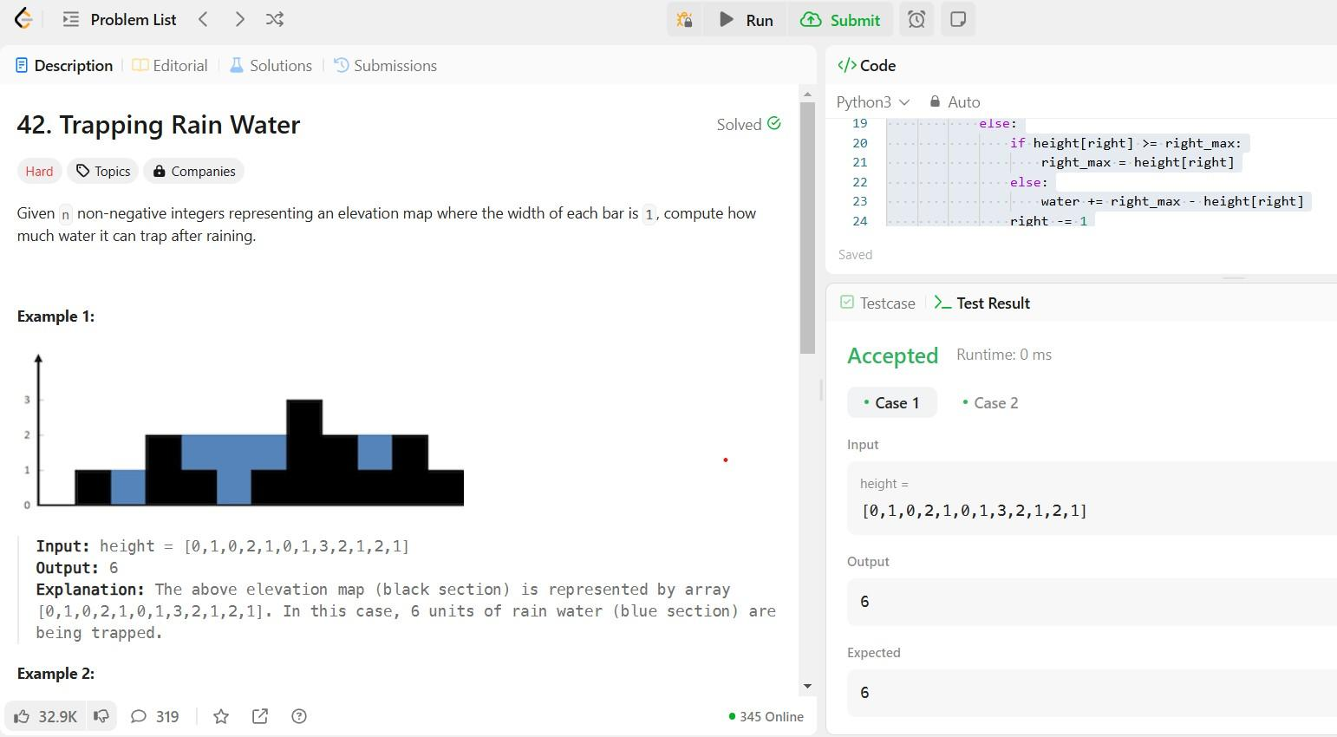

**CODE:**

**from typing import Optional**

**# Definition for a binary tree node. class TreeNode:**

**def**  **init** **(self, val=0, left=None, right=None): self.val = val**

**self.left = left self.right = right**

**class Solution:**

**def flatten(self, root: Optional[TreeNode]) -> None: """**

**Do not return anything, modify root in-place instead. """**

**if not root:**

**return**

**# Helper function to recursively flatten the tree def flatten_tree(node):**

**if not node:**

**return None**

**# Flatten the left and right subtrees left_tail = flatten_tree(node.left) right_tail = flatten_tree(node.right)**

**# If there is a left subtree, attach it to the right of the current node**

**if node.left:**

**if left_tail:**

**left_tail.right = node.right # Connect the tail of the left subtree to the start of the right subtree**

**node.right = node.left # Move the left subtree to the right node.left = None # Set the left child to None**

**node**

**# Return the tail of the flattened tree**

**return right_tail if right_tail else left_tail if left_tail else**

**flatten_tree(root)**

**OUTPUT:**

